**Performance Testing**

**Introduction**

Performance Testing is a type of software testing that focuses on evaluating the performance characteristics of a system, application, or software under various conditions. The primary goal is to ensure that the application meets certain performance criteria, such as response time, scalability, and reliability, under varying loads.

**Overview of PT and its Importance**

Performance testing is crucial to ensure that an application or system meets the performance expectations and requirements defined by stakeholders. The performance of an application can directly impact user experience, customer satisfaction, and the overall success of the software. Performance testing helps identify bottlenecks, weaknesses, and areas for improvement in the system.

Key aspects:

Response Time: Measures the time taken by the system to respond to a user request.

Throughput: Measures the number of transactions or requests processed by the system in a given time period.

Scalability: Evaluates how well the system can handle increased load and whether it can scale to support a growing user base.

Reliability: Assesses the system's ability to perform consistently under varying conditions and over an extended period.

Stability: Ensures that the system remains stable and does not crash or degrade performance under stress.

**Types of Performance Testing:**

Load Testing: Determines how the system performs under normal and peak load conditions.

Stress Testing: Evaluates the system's behavior under extreme conditions, often beyond its capacity limits.

Endurance Testing: Assesses the system's performance over an extended period to identify issues related to sustained usage.

Scalability Testing: Measures the system's ability to scale up or down to accommodate changes in load.

Volume Testing: Checks the system's performance when dealing with a large volume of data.

Spike Testing: Examines the system's response to sudden spikes or fluctuations in user activity.

**Performance Testing Objectives:**

Identify Performance Bottlenecks: Discover areas in the system where performance issues might arise.

Ensure Response Time Compliance: Validate that the application responds within acceptable time limits.

Evaluate Scalability: Assess the system's ability to scale with increased user loads.

Verify Stability: Confirm that the application remains stable under varying conditions.

Ensure Reliability: Guarantee consistent and reliable performance over time.

Optimize Resource Utilization: Maximize the efficient use of hardware resources.

**Non-Functional Requirements (NFRs):**

Non-Functional Requirements (NFRs) are criteria that define the quality attributes of a system, including its performance characteristics. These requirements focus on aspects such as performance, usability, security, reliability, and maintainability. NFRs play a crucial role in guiding the performance testing efforts and setting the expectations for the system's behavior under different conditions.

Common NFRs related to performance testing include:

Response Time: Specifies the maximum acceptable time for the system to respond to user interactions.

Throughput: Defines the desired number of transactions or requests the system should handle per unit of time.

Scalability: Outlines expectations for the system's ability to handle increased loads by adding resources.

Availability: Indicates the desired level of uptime or availability for the system.

Reliability: Specifies the system's expected behavior under normal and exceptional conditions.

Security: Addresses performance-related aspects of security, such as response times for authentication and authorization processes.

Understanding and aligning performance testing with NFRs is essential for ensuring that the software meets the specified quality attributes and performs effectively in real-world scenarios.

======================================

**Defining and Prioritizing NFRs:**

**Defining NFRs:**

Non-Functional Requirements (NFRs) are specifications that describe how a system should perform rather than what it should do. They include aspects such as performance, reliability, usability, security, and scalability.

NFRs are crucial for setting expectations and criteria related to the quality attributes of the software.

**Prioritizing NFRs:**

Prioritization is essential to focus on critical aspects of performance that directly impact the user experience and business goals.

Stakeholders collaborate to identify and prioritize NFRs based on business needs, user expectations, and system requirements.

NFRs vs. FR:

NFRs:

Address quality attributes such as performance, reliability, usability, and security.

Focus on how well the system performs under different conditions.

Examples include response time, throughput, and system availability.

FRs:`

Define specific functionalities and features the system must deliver.

Address what the system should do under various scenarios.

Examples include user authentication, data processing, and report generation.

**Performance Testing Life Cycle (PTLC):**

1. Planning:

Identify objectives, scope, and stakeholders.

Define performance metrics and success criteria.

Plan resource requirements, testing environments, and schedules.

1. Design:

Create performance test scenarios based on NFRs.

Develop test scripts and data.

Design workload models and simulate user behaviour.

1. Execution:

Implement the performance test plan.

Execute test scenarios in a controlled environment.

Monitor system performance and gather metrics.

1. Analysis:

Analyze test results against predefined performance metrics.

Identify performance bottlenecks and issues.

Provide recommendations for improvements.

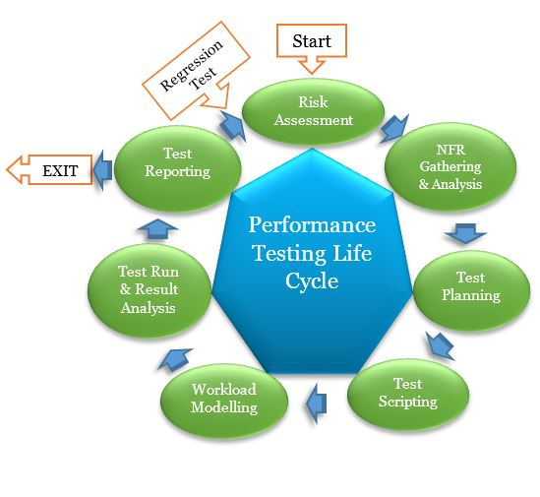

1. Non-Functional Requirements Elicitation and Analysis

Understanding non-functional requirement is the inception and most critical phase in PTLC.

Entry Criteria

Application Under Test (AUT) Architecture

Non-Functional Requirement Questionnaire

Tasks

Understanding AUT architecture

Identification of critical scenarios and understanding

Understanding Interface details

Growth pattern

Exit Criteria

Client signed-off NFR document

2. Performance Test Strategy

This phase defined how to approach Performance Testing for the identified critical scenarios. Following are to be addressed during this phase.

What kind of performance testing?, Performance tool selection, Hardware and software environment set up

Entry Criteria

Signed-off NFR document

Activities

Prepare the Test Strategy and Review

Data set up

Defining in-scope and out-scope

SLA

Workload Model

Prepare Risks and Mitigation and Review

Exit Criteria

Baselined Performance Test Strategy doc

3. Performance Test Design

This phase involves with the script generation using identified testing tool in a dedicated environment. All the script enhancements should be done and unit tested.

Entry Criteria

Baselined Test Strategy

Test Environment

Test Data

Activities

Test Scripting

Data Parameterization

Correlation

Designing the action and transactions

Unit Testing

Exit Criteria

Unit tested performance scripts

4. Performance Test Result Analysis

This phase involves dedicated to the test engineers who design scenarios based on identified workload and load the system with concurrent virtual users (VUsers).

Entry Criteria

Baselined Test scripts

Activities

Designing the scenarios

Loading the test script

Test script execution

Monitoring the execution

Collecting the logs

Exit Criteria

Test script execution log files

5. Performance Test Result Analysis

The collected log files are analyzed and reviewed by the experienced test engineers. Tuning recommendation will be given if any conflicts identified.

Entry Criteria

Collected log files

Activities

Create graphs and charts

Correlating various graphs and charts

Prepare detailed test report

Test report analysis and review

Tuning recommendation

Exit Criteria

Performance Analysis Report

6. Benchmark and Recommendations

This is the last phase in PTLC which involves benchmarking and providing recommendation to the client.

Entry Criteria

Performance Analysis Report

Activities

Comparing result with earlier execution results

Comparing with the benchmark standards

Validate with the NFR

Prepare Test Report presentation

Exit Criteria

Performance report reviewed and baselined

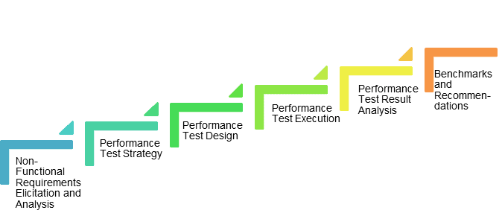

**Phases of PTLC:**

* Initiation:

Define goals, objectives, and scope.

Identify stakeholders and their expectations.

Establish performance criteria and success metrics.

* Requirements Analysis:

Identify and analyze NFRs.

Collaborate with stakeholders to gather performance expectations.

Define the testing approach and strategy.

* Test Planning:

Develop a detailed performance test plan.

Define test scenarios, workload models, and test scripts.

Plan for resource allocation and scheduling.

* Test Design:

Create detailed performance test scripts.

Design test data and workload models.

Define monitoring and measurement criteria.

* Test Execution:

Implement the performance test plan.

Execute test scenarios in the testing environment.

Monitor and measure system performance.

* Analysis and Reporting:

Analyze test results and identify performance bottlenecks.

Generate performance reports.

Provide recommendations for optimization.

* Closure:

Document lessons learned and best practices.

Obtain sign-off from stakeholders.

Archive test artifacts and results.

The PTLC is iterative, and feedback from each phase contributes to refining the performance testing process. Collaboration between development, testing, and operations teams is crucial for successful performance testing and optimization efforts.

**Implications for Performance Testing:**

The choice of application architecture has profound implications for performance testing. Different architectures pose unique challenges and considerations:

* Scalability Challenges:

Monolithic Architectures: May face challenges in scaling due to the need to scale the entire application.

Microservices Architectures: Scalability can be achieved by scaling individual services independently.

* Inter-Service Communication:

Microservices and SOA: Performance testing must assess the efficiency of inter-service communication through APIs.

* Data Management:

Distributed Architectures: Testing data consistency and management across distributed components is critical.

* Resource Allocation:

Serverless Architectures: Testing should consider the dynamic allocation and deallocation of resources.

* Latency and Throughput:

Event-Driven Architectures: Testing should evaluate how components handle and process events efficiently.

* Dependency Management:

Client-Server and Microservices Architectures: Dependencies between components should be tested for optimal performance.

* Third-Party Services:

Serverless and Microservices Architectures: Testing must consider the performance of third-party services and APIs.

* Dynamic Environments:

Serverless Architectures: Dynamic scaling and the serverless nature require unique testing approaches.

* Integration Points:

Client-Server and SOA: Testing should focus on integration points and ensure seamless communication.

* Security Implications:

Different architectures may have varied security implications, and performance testing should assess the impact on security measures.

* Resource Utilization:

Understanding how resources are utilized in different architectural styles is crucial for effective performance testing.